**Face Recognition Attendance System**

Flow process:

(Background works)

* Storing Train Data(Person faces)
* Training Data using Shape Predictor facial landmarks
* Checking for the match in the database.
* Storing the photos in the database using cloud.
* Encrypting the data using Base64 encryption.
* Sending the encrypted data to admin using cloud
* Forming QR code using QZ bar
* Sending the QR code to mail

(Frontend)

* Using HaarCascade to detect the face.
* Using Dlib CNN’s-Shape Predictor 68 facial landmarks to recognize the face.
* Sending message as authorized or un- authorized person(Using Python Code).
* Showing different options for user( Using python code)
* Drowsiness detection using facial landmarks.
* Alarm turns on and off(Python code)
* Matching the QR code sent to the mail.(Using QZ bar and python)

**Existing Models/Methods:**

|  |  |  |  |
| --- | --- | --- | --- |
| **No.** | **Methods** | **Advantages** | **Disavantages** |
| **1.** | Classical face recognition algorithms | Focuses on local structure of the manifold. These methods project face onto linear subspace spanned by the eigenface images. The distance from face space is orthogonal to the plane of mean image, so may be easily turned to Mahalanobis distances with probabilistic interpretation | These methods may fail to adequately represent faces when large variations in illumination facial expressions and other factors occur. Regarding to , applying kernel‐based nonlinear methods do not produce a significant improvement comparing to linear methods. LLE, LLP and LBP brought simple and effective way to describe neighbouring changes in face description. Subspace approaches were applied in DCV‐ and SVM‐based methods. Preserving the local structure between samples is the domain of NPP and ONPP methods. The problem is that it is still unclear how to select the neighbourhood size or assign optimal values for them. |
| **2.** | Artificial neural networks | Radial basis function artificial neural network is naturally integrated with non‐negative matrix factorisation. Also other approaches for process simplification regarding to ANNs native linearisation feature and computation speed up. Ideal solution, especially for recognising face images with partial distortion and occlusion | The main disadvantage of this approach is requirement of greater number of training samples (instead one or limited number). It is inaccurate in the same way like other statistically based methods |
| **3.** | Gabor wavelets | The Gabor wavelets exhibit desirable characteristics of capturing salient visual properties like spatial localisation orientation selectivity and spatial frequency. Different biometrics applications favour this approach | The drawback of the Gabor‐based methods is significantly high dimensionality of the Gabor feature space since face image is convolved with a bank of Gabor filters. Approach is computationally intensive and impractical for real‐time applications. Additionally, simplified Gabor features are sensitive to lighting variations |
| **4.** | **OUR METHOD**  (Face descriptor‐based methods) | The main idea behind developing image descriptors is to learn the most discriminant local features that minimise difference between images of the same individual and maximise that between images from the other people. These methods are discriminative and robust to illumination and expression changes. They offer compact, easy to extract and highly discriminative descriptor. | Approach is computationally intensive during descriptor extraction stage, but encouraging simplicity and performance in reference to online applications |

Accuracy for face_recognition model:

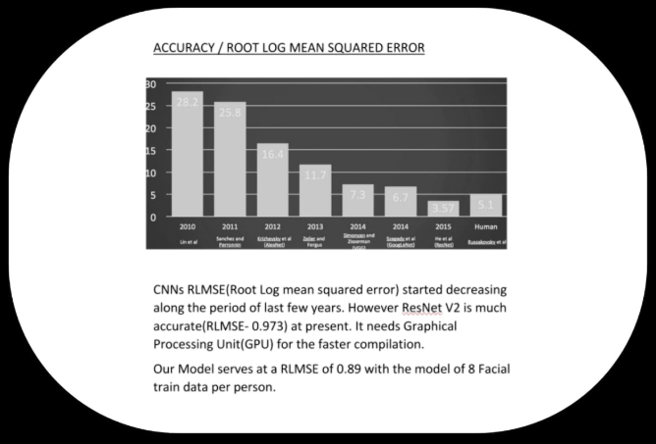

**Team Y-Axis**

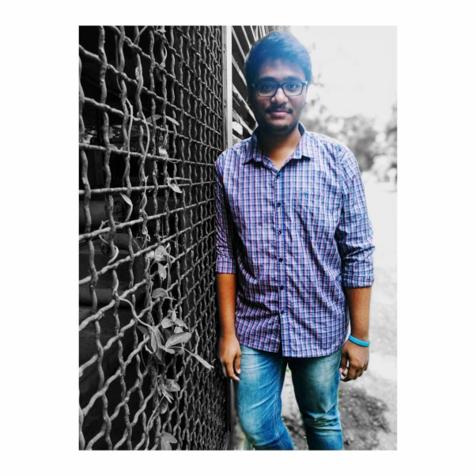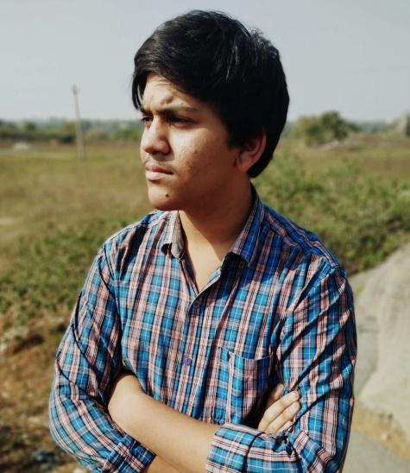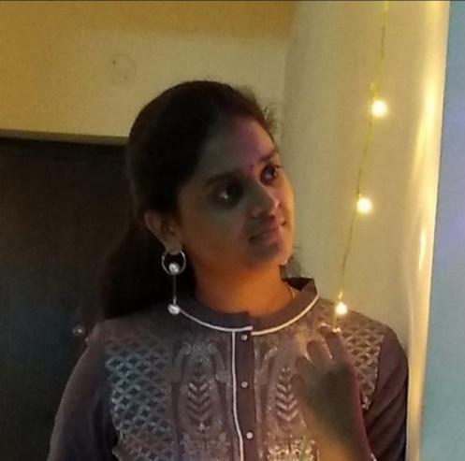

P V SAI KRITHIK

K SAI PRATYUSHA

M T ADARSH RAGHAVAN